# Gear Fit Hardware:

Then have a look at the internals (teardown):

* 1.84” Curved Super AMOLED touchscreen display (432 x 128 pixels)
* 180 MHz ARM Cortex-M4 CPU
* Accelerometer, gyroscope, and heart rate sensor (an optical one, see right:)
* Battery good for 3-4 days of normal use
* Bluetooth 4.0 LE

[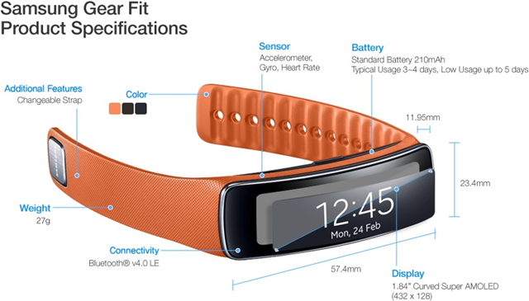](https://lazure2.files.wordpress.com/2014/05/image13.png)

Figure 1: Gear Fit Product Specification

[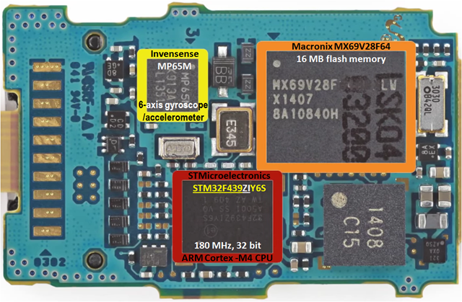](https://lazure2.files.wordpress.com/2014/05/image8.png)

Figure 2: Gear Fit main board

[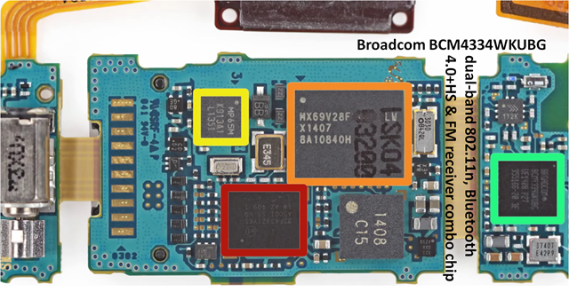](https://lazure2.files.wordpress.com/2014/05/image9.png)

Figure 3: Gear Fit Bluetooth Chip

[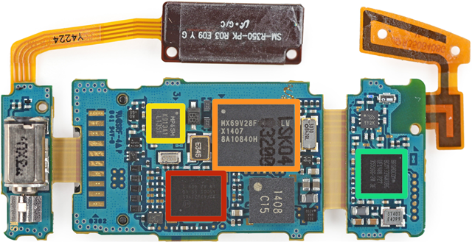](https://lazure2.files.wordpress.com/2014/05/image10.png)

Figure 4: Hardware Overview

[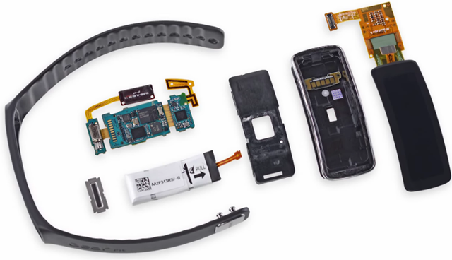](https://lazure2.files.wordpress.com/2014/05/image11.png)

Figure 5: Hardware main component

# Component level details:

Only the following key components are considered here:

* The STM32F439ZIY6S High-performance Microcontroller of the STM32 F4 Series MCUs from STMicroelectronics
* The MPU-6500 Six-Axis (Gyro + Accelerometer) MEMS Motion Tracking™ Devices from InvenSense (marked as MP65M)
* BCM4334WKUBG Single-Chip Dual-Band Combo Device Supporting 802.11n, Bluetooth 4.0+HS & FM Receiver from Broadcom

## The STM32F439ZIY6S High-performance Microcontroller of the STM32 F4 Series MCUs from STMicroelectronics:

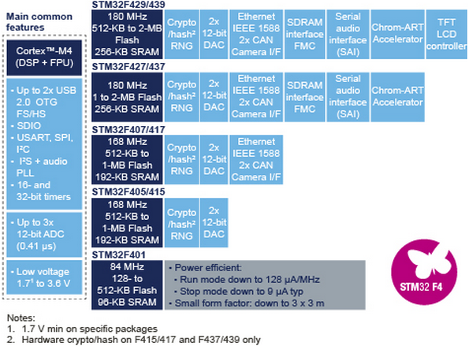

*The high-performance*[*STM32F429/439*](http://goo.gl/9Yu6ok)*series now entering production has the industry’s highest performing ARM®Cortex™-M4 core, at 180MHz, able to achieve 225DMIPS (Dhrystone MIPS) and 608 CoreMark scores using industry-standard performance metrics thanks to the ST adaptive real-time accelerator (ART Accelerator) allowing zero-wait execution from Flash. These devices offer up to 2Mbyte of dual-bank Flash allowing safe system upgrades in the field, ST’s unique Chrom-ART Accelerator™ giving customers a competitive edge in graphics processing, and an integrated TFT-LCD controller.*

*The*[*STM32F427/437*](http://goo.gl/wvHIw0)*series [*announced [in November 2012](http://www.st.com/web/en/press/en/p3357) with the 168MHz core which entered full production [in February 2013](http://www.st.com/web/en/press/en/p3393)*] is also entering full production, upgraded with the 180MHz core, dual-bank memory, and other features of the STM32F429/439 excluding the TFT-LCD controller.*

*Also entering volume production is the STM32F401 microcontroller announced*[*in April 2013*](http://www.st.com/web/en/news/n3418)*. The device balances high performance (105 DMIPS and 285 CoreMark, and zero-wait Flash execution with the ART Accelerator), power efficiency and high feature integration in packages as small as 3x3mm.*

*The Cortex-M4 processor extends the use of Cortex-M cores to applications requiring intensive mathematical computation,” said Semir Haddad, 32-bit MCU Marketing Manager of ST Microcontroller division. “A product line based on the Cortex-M4 processor will complement our line of STM32 microcontrollers, giving our customers the ability to combine the scalability of STM32 with enhanced signal processing capability.*